RadioLink Electronic Limited

www.radiolink.com

RadioLink OSD Information Telemetry Module PRM-03

OSD Telemetry Sensor: PRM-03

OSD Telemetry module transmits the data from the flight controller and shows the data of SPEED, RISE, THRO, VOLT, LATI, LONG, ALT, GPS, RSSI, MODE, YAW, ROLL, PITC, DIST in the display screen of AT9, AT9S, AT10 or AT10II.
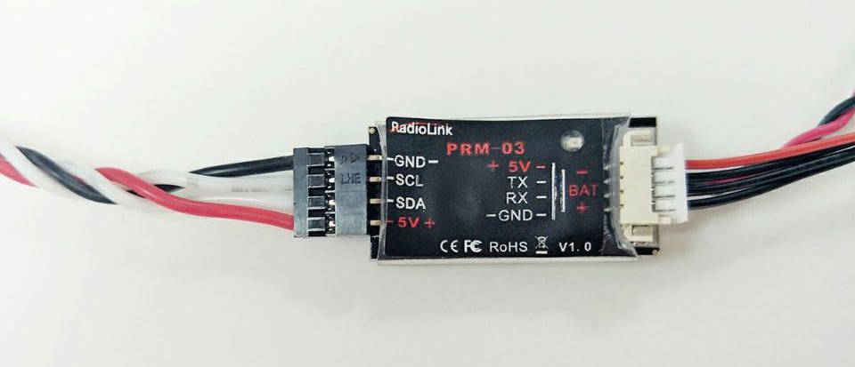

1. Introduction:

(1). Size: 27*13mm

(2). Weight: 6g(including the wires)

(3). So far, OSD information telemetry module PRM-03 is compatible with flight controller PIX and APM.

(4). Support RadioLink receivers R9D, R9DS, R10D, R10DII, R10DS and R12DS.

(5). PRM-03 can telemetry Speed, Rise, Throttle, Voltage, Longitude, Latitude, Altitude, GPS, RSSI, Flight Mode, YAW, ROLL, PITC, Distance.

(6). PRM-03 is compatible with 1 cell to 12 cells battery(3.7~50.4V).

Pay Attention： The old version AT9 and AT10 have to upgrade the firmware when if use PRM-03 to telemetry OSD information. Upgrade AT9 firmware to V1.2.6(OSD) or upgrade AT10 firmware to V1.0.6(OSD).

2. Connection

(1) Connect one end of the telemetry module PRM-03 to R9D/R9DS/R10D/R10DII/R10DS/R12DS and the other end to battery if you just need feedback battery voltage. Same function as RadioLink PRM-01 if you connect like that.
RadioLink Electronic Limited

www.radiolink.com
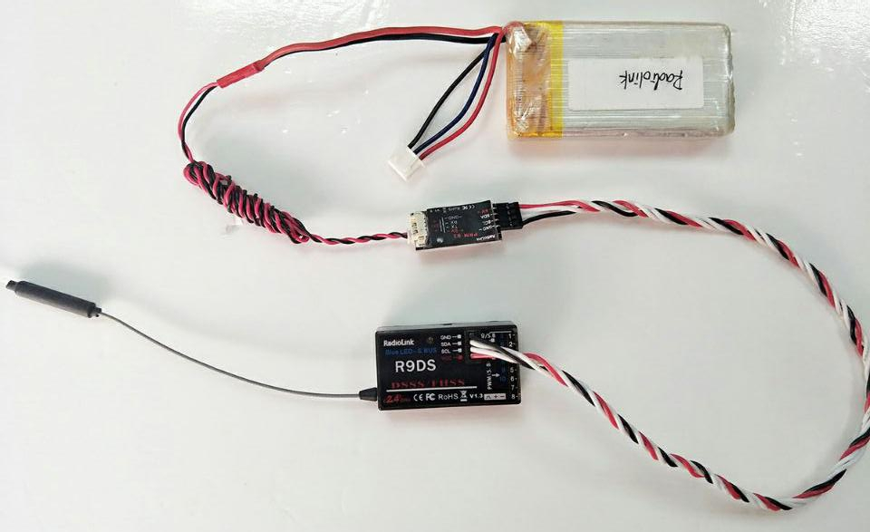

(2) If you want to feedback Speed, Rise, Throttle, Voltage, Longitude, Latitude, Altitude, GPS, RSSI, Flight Mode, YAW, ROLL, PITC, Distance information, please connect one end of the OSD information telemetry module PRM-03 to R9D/R9DS/R10D/R10DII/R10DS/R12DS and the other end to the TELEM port of PIX or APM.

For example: connect to PIX:
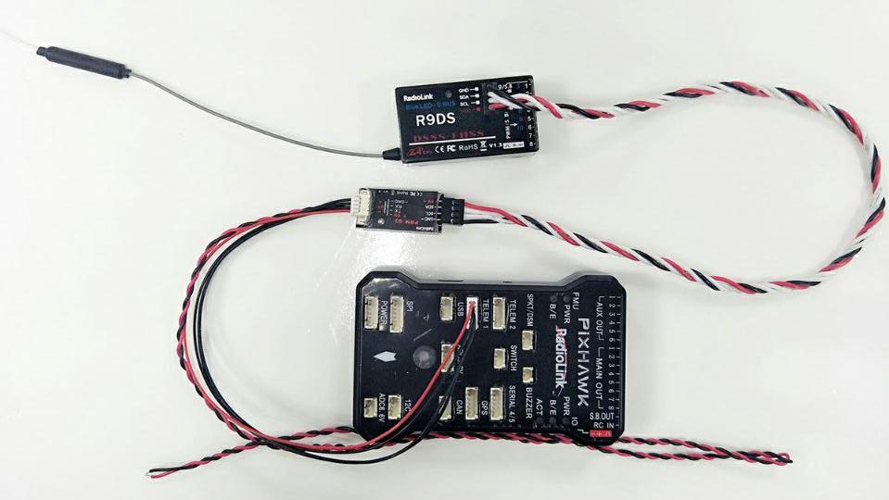
RadioLink Electronic Limited

www.radiolink.com

The information will display on the RECEIVE menu.

Displaying effect (AT9S)
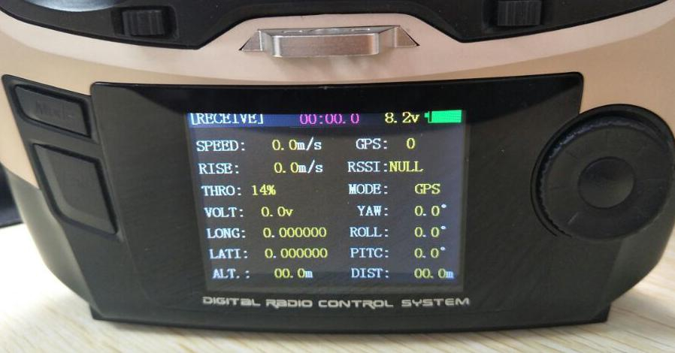

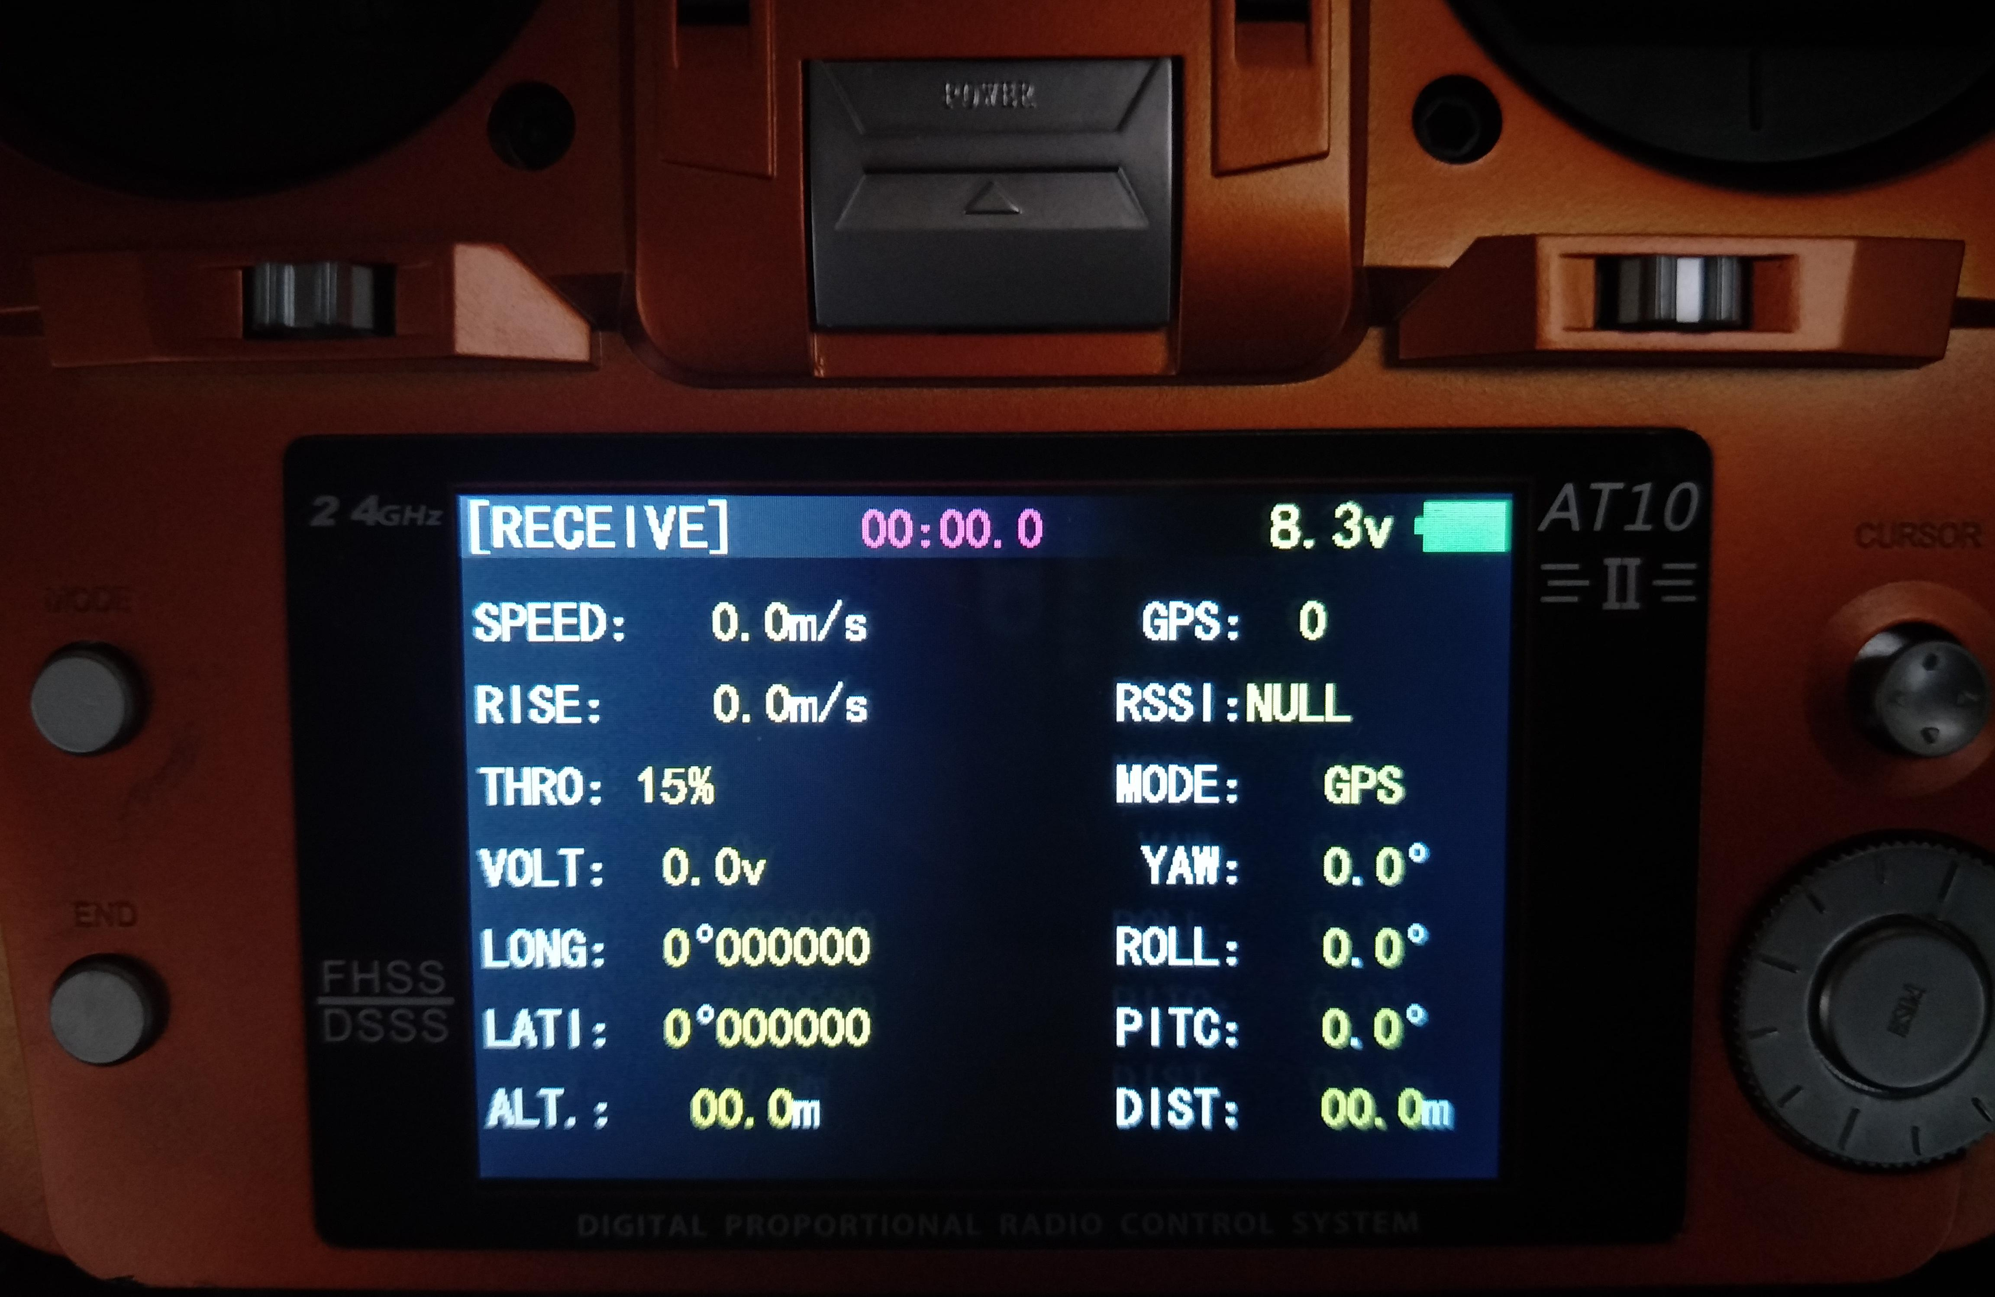
Displaying effect (AT10)

