
Loading VTX File Tutorial

- The first step is to connect the flight controller to the computer. connection the Betaflight and open the interface of the VTX and then choose
"loading from file"

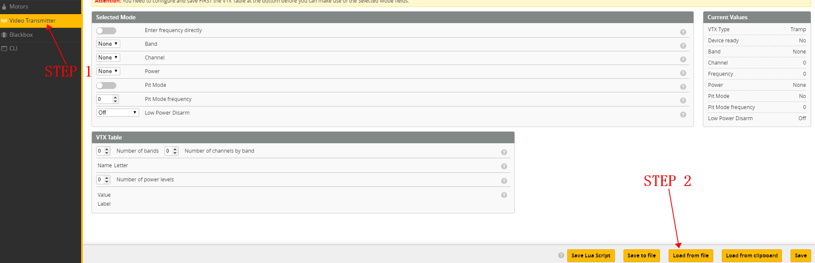
2.Select the corresponding transmission file,which can be downloaded on the official website or you can contact official support to get the file.
After selecting the file, please click “Open”.

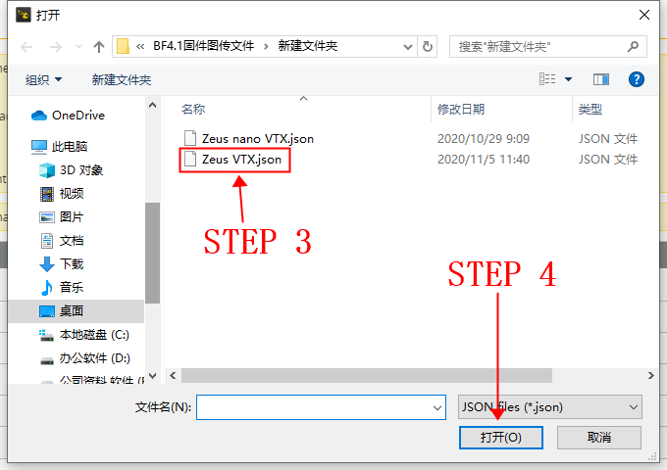
3.After opening the file, select the frequency and channel and power you need and click Save.
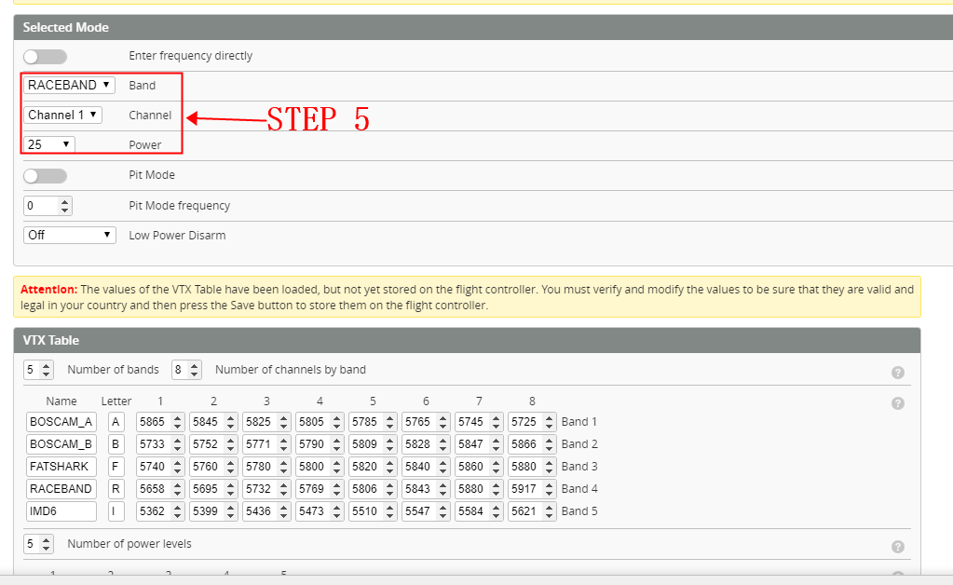
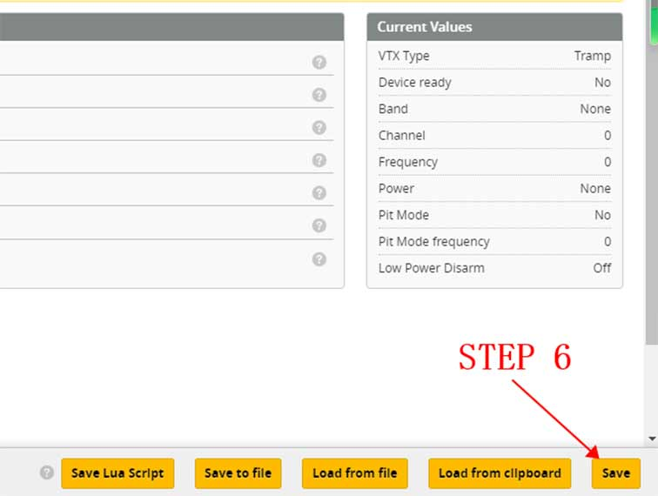
4.This tutorial is for firmware 4.1 and above of BF

