Zeus F722
mini Flight Control
Manual
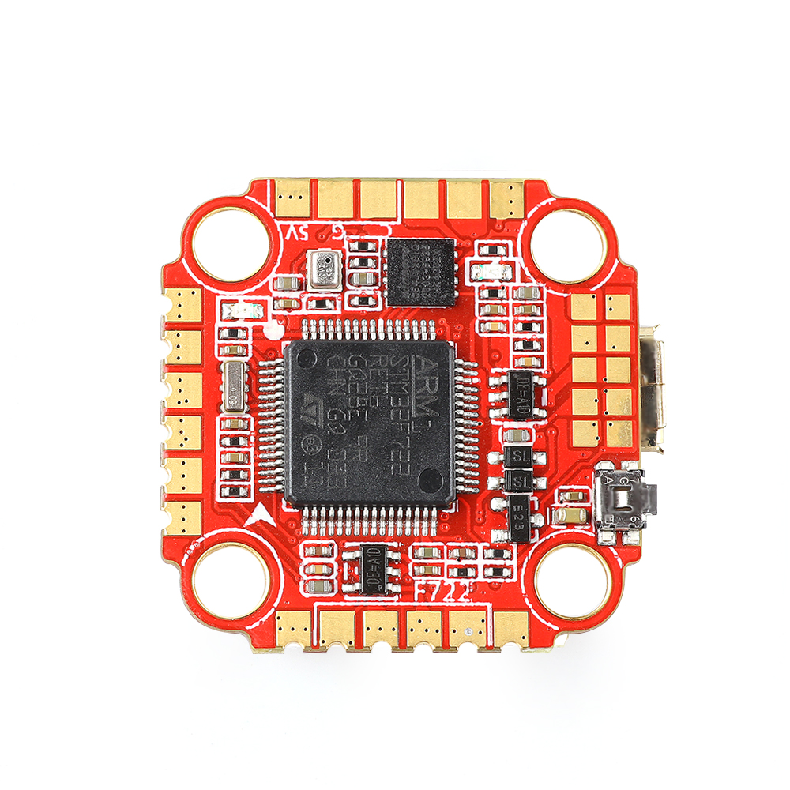

Contents

Product Specifications.............................................................................................................................1
Interface Description...............................................................................................................................2
Check the flight control drive................................................................................................................3
Calibration accelerometer......................................................................................................................4
UART serial port use.................................................................................................................................5
Select aircraft model.................................................................................................................................6
Choose ESC protocol..................................................................................................................................7
Select ESC telemetry..................................................................................................................................8
Voltage and current parameters setting.............................................................................................9
Setting up the receiver..............................................................................................................................10
VTX serial port use. VTX uses OSD smart audio..............................................................................11
GPS parameters setting...........................................................................................................................12
Check receiver signal................................................................................................................................13
Select flight mode startup mode...........................................................................................................14
OSD settings.................................................................................................................................................15
LED settings.................................................................................................................................................16
Troubleshooting.........................................................................................................................................17
.......................................................................................

Package IncIuded

Zeus F722 mini Flight Controller  *1 | Accessory Bag*1

1.Product Specifications

Product parameters
Model | Zeus F722 mini Flight Controller
Weight | 4.2g
Usage | for 100mm-450mm Frame Kit
MPU | MPU6000
CPU | STM32F722 RET6
Black Box | 8M
Support receiver | SBUS .IBUS.DSMX/R9MM
Input Voltage | 3-6S Lipo
BEC Output | 9V/1A.5V/2A
Size | 28.2x28.1mm board, M2/M3  mounting holes

2.Interface Description
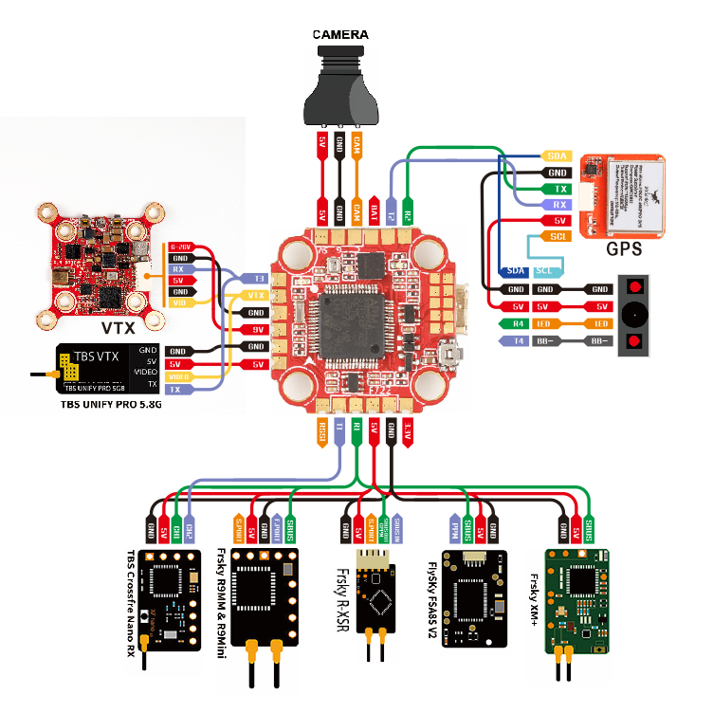

3.Check the flight control drive
- Long Press BOOT buttons.connect USB.The system automatically install the driver
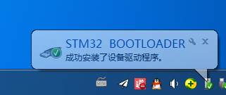
2.Driver cannot be installed, please download ImpulseRC_Driver_Fixer
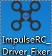
3.Double-click on the run(Plug in the flight controller to automatically install the driver)
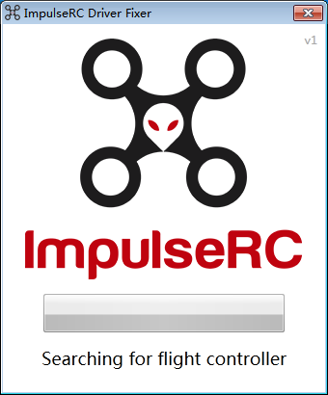
4.open betaflight configurator ，enter DFU mode
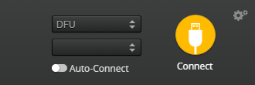

5.Click Select firmware version
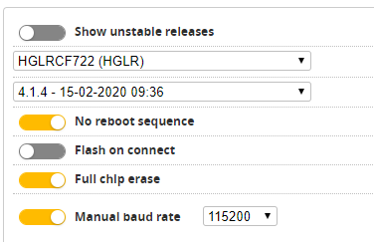

6.Click Load firmware. Waiting for completion It will be prompted upon completion.

- open betaflight configurator.Controller plugged into the computer. Betaflight Automatically assigned port，click “Connect” Enter setup interface（Different computer COM）
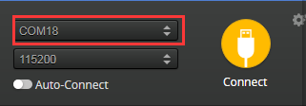

- Calibration accelerometer
- Put the aircraft horizontal and click“Reset Z axis”
Click again

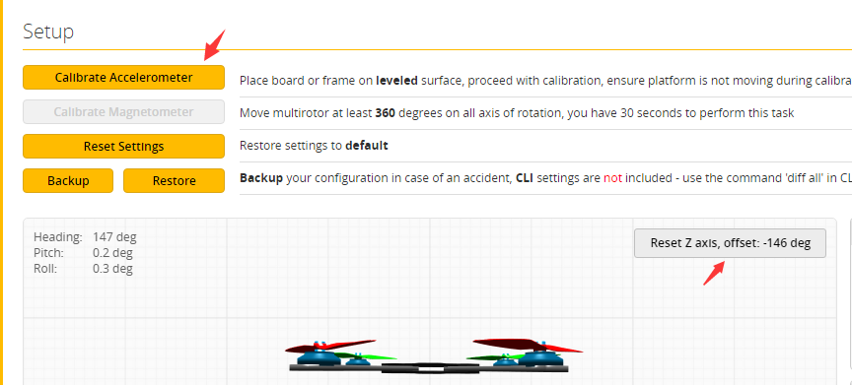

5.UART serial port use
1.UART1 uses the receiver
2.UART2 uses GPS
3.UART3 uses VTX image transmission
4.UART4 uses DJI
5.UART6 uses ESC telemetry

6.Select aircraft model

1.ClickSelect model
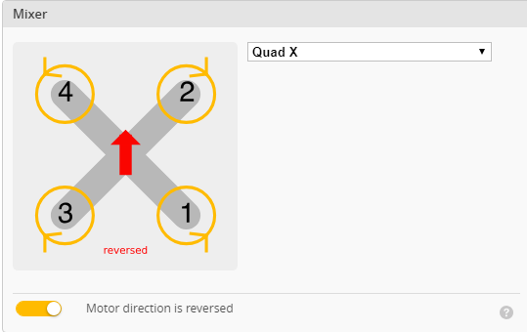

2.Click Click “I understand the risks”Push Master to check motor steering“Master”Steering can be changed at BLHeliSuite
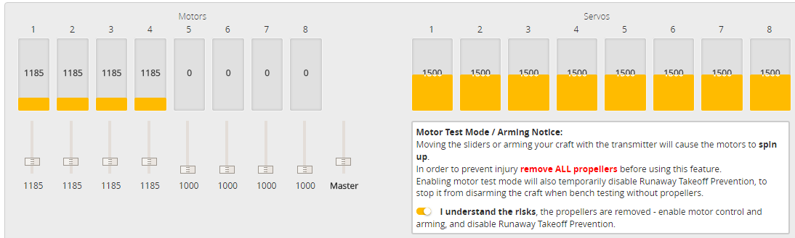
7.Choose ESC protocol
1.Choose the right ESC protocol, the optional universal protocol DSHOT600.
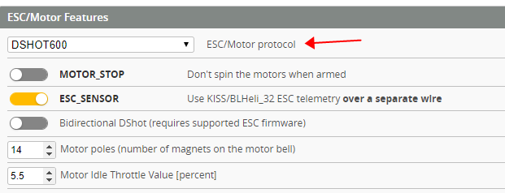
8.Turn on ESC telemetry
1.Use BLHeli_32 ESC telemetry over a separate wire
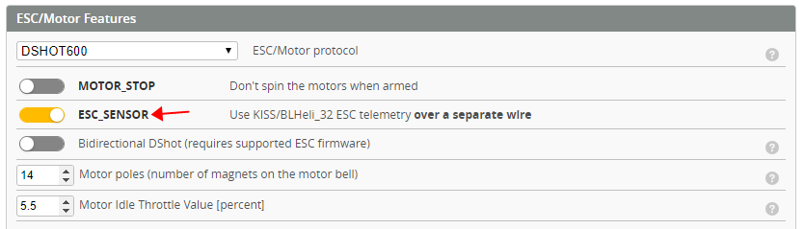
2.Open ESC telemetry serial port.TX on the ESC needs to be connected to the RX6 on the flight controller to use the ESC telemetry
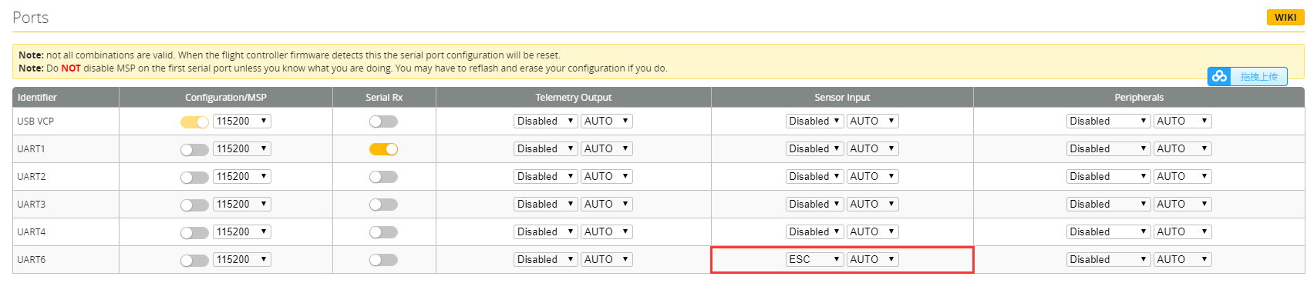
3.View telemetry data on OSD
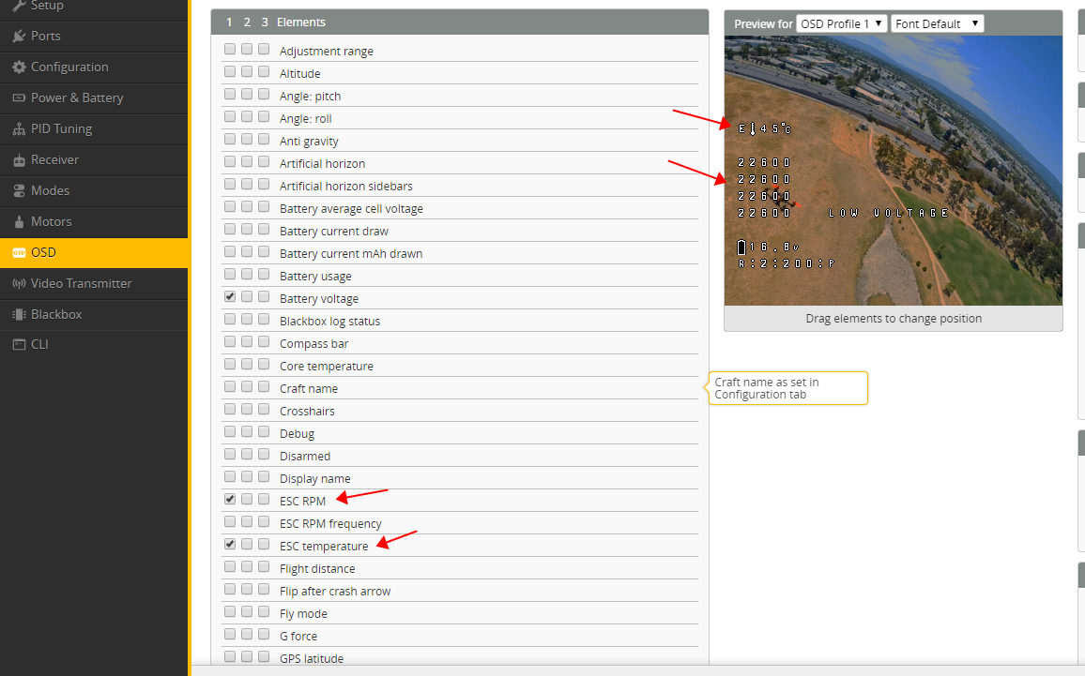
9.Voltage and current parameters setting
1.ClickSetting parameters
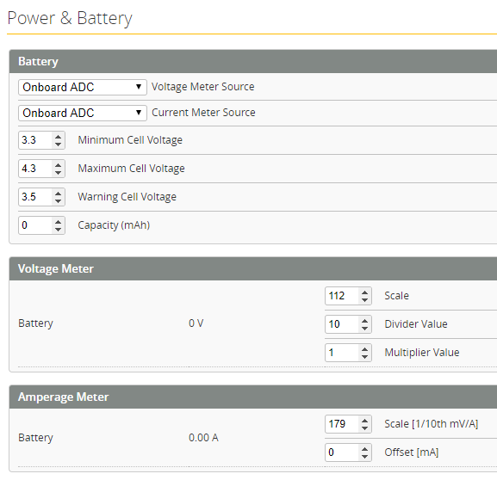
10.Setting up the receiver
1.Receiver connection diagram
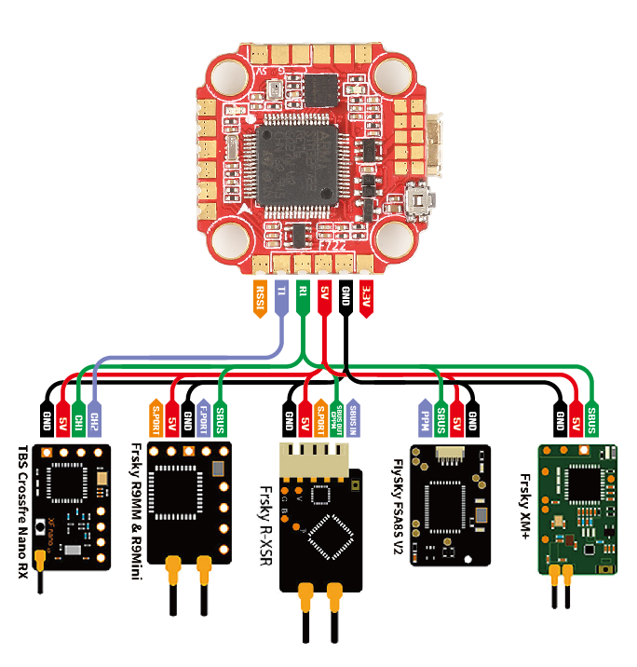
2.Click.have found“UART1”Open the receiver serial port
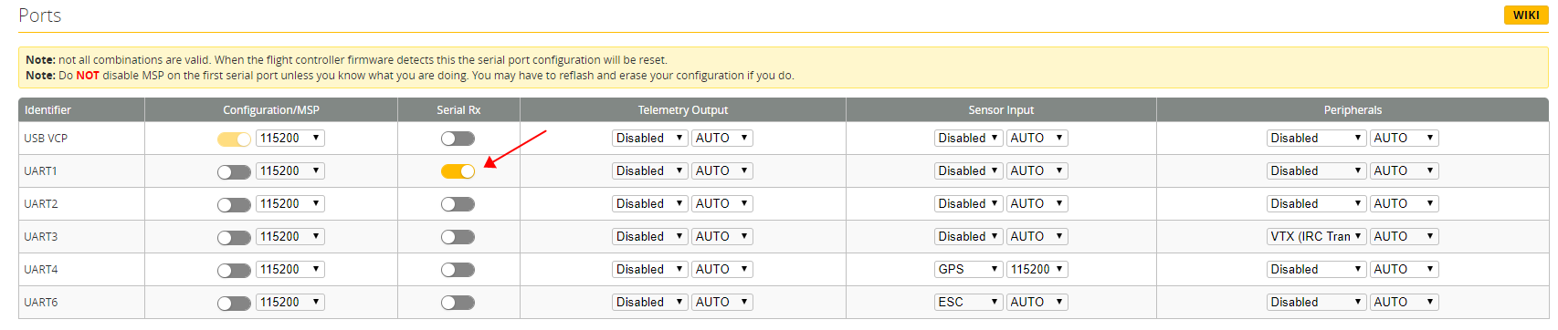

3.Set the SBUS receiver
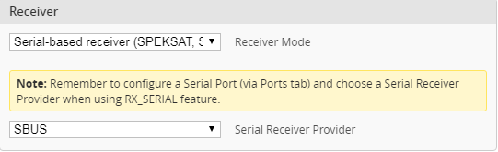
4.Set the DSMX receiver
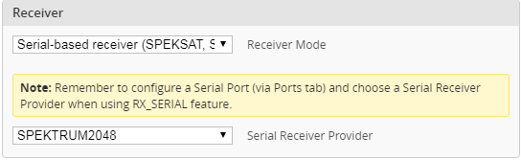

11.VTX serial port use. VTX uses OSD smart audio
1.VTX connection diagram
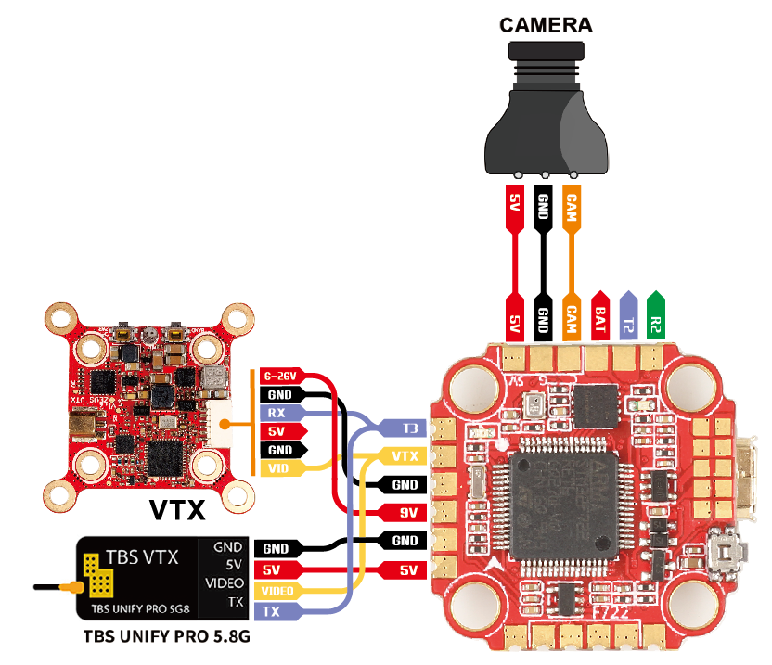

- DJI FPV Air Unit wiring
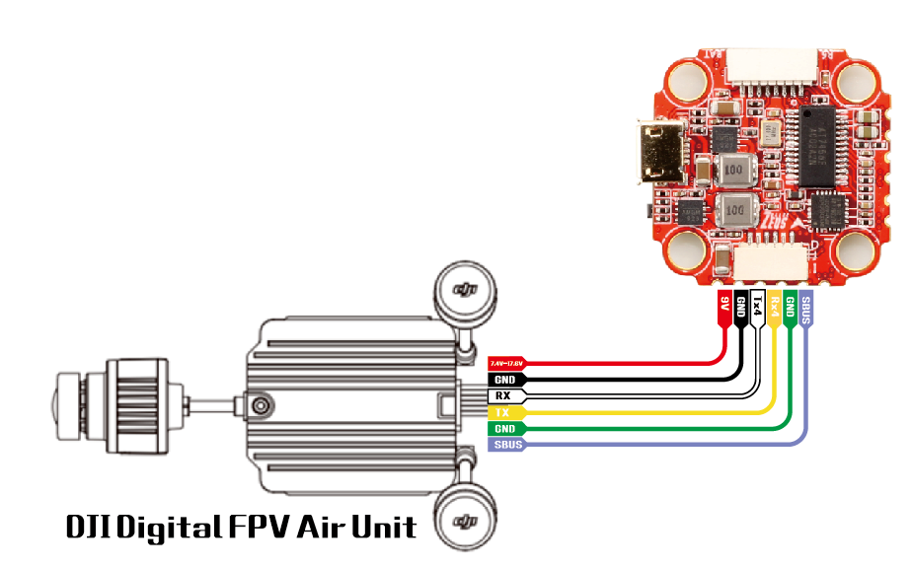
3.VTX serial port opens. The protocol is selected according to its own VTX protocol.
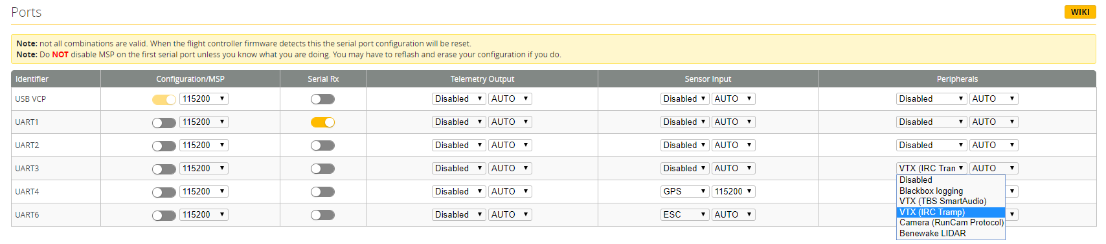

4. DJI serial port opens
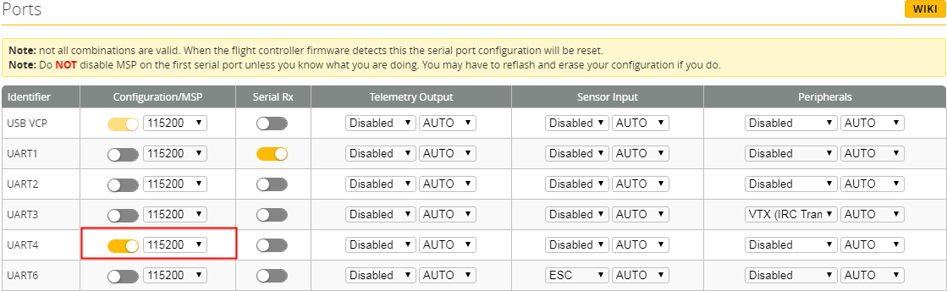
5.Use OSD to adjust VTX
which displays information like battery voltage and mAh consumed while you fly. In addition, the Betaflight OSD can be used to configure the quadcopter, making in-field adjustments and tuning more convenient.
MODE2 MODE1

The graphics above show the stick command to bring up the OSD menu. The stick command is: throttle
centered, yaw left, pitch forward. The exact stick command therefore depends on which mode your
transmitter sticks are in.
In the OSD menu, use pitch up/down to move the cursor
between menu items. When a menu option has a > symbol
to the right of it, this indicates that it contains a sub-menu.
Roll-right will enter the sub-menu. For example, in the
screen to the right, moving the cursor to “Features” and
then moving the roll stick to the right will enter the
“Features” sub-menu.

If you are using a video transmitter that supports remote
configuration, enter the “Features” menu to configure the
vTX. From there, enter either “VTX SA” if you are using
SmartAudio (TBS Unify) or “VTX TR” if you are using IRC
Tramp Telemetry.

To adjust PIDs, rates, and other tuning-related parameters,
enter the “Profile” sub-menu.
In the “Scr Layout” sub-menu, you can move the OSD
elements (like battery voltage, mAh, and so forth) around on
the screen.

The “Alarms” sub-menu lets you control when the OSD will
try to alert you that battery voltage is too low or mAh
consumed is too high.
When a parameter can be modified, the parameter’s current
value will be shown on the right-hand side of the screen. In
this case, roll left/right will adjust the parameter up and
down.
The screen to the right shows the current vTX settings. From
here, you can change the frequency band, channel, and
power level of the video transmitter. After making the
changes, move the cursor to “Set” and press roll-right to
confirm the settings.

12.GPS parameters setting
1.GPS connection diagram
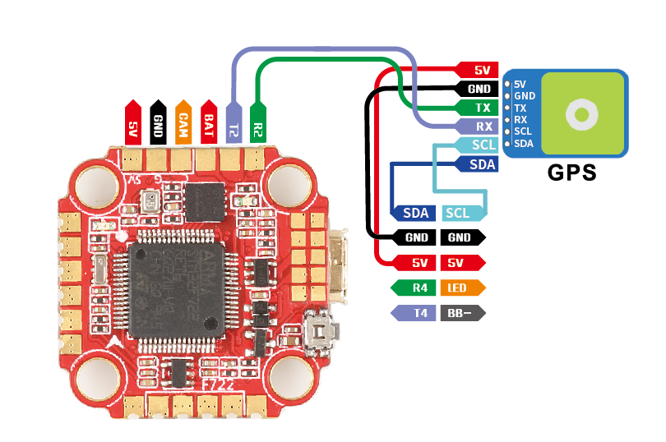
2.Open the GPS serial port
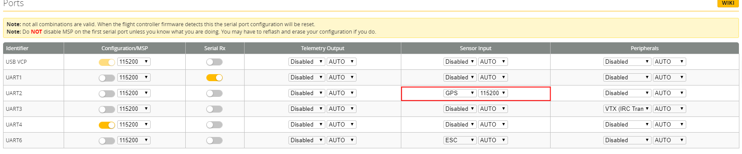
3.When using the GPS function, remember to configure the serial port (via the Ports tab).
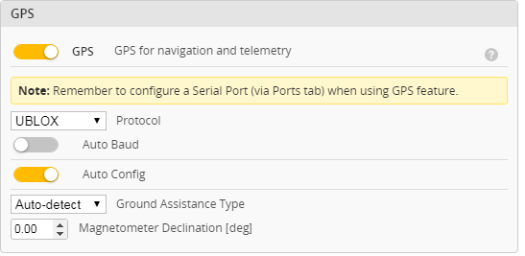
13.Check receiver signal
1.ClickCheck the remote control output signal
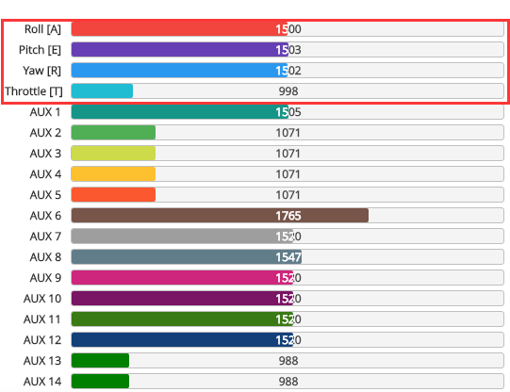
14.Select flight mode startup mode
1.Clickset up the function of remote control switch across the channel (below are for reference only)
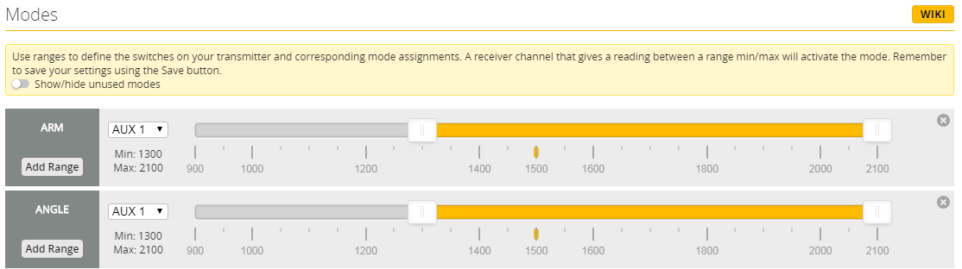
15.OSD settings
1.Click the OSD Settings, according to the need to choose, drag the OSD schematic diagram of the parameters can be adjusted.
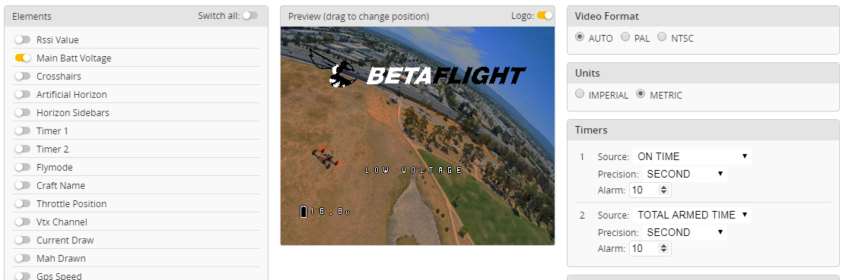
- LED settings
1.ClickTurn on LED support
2.Click.Clickset according to need
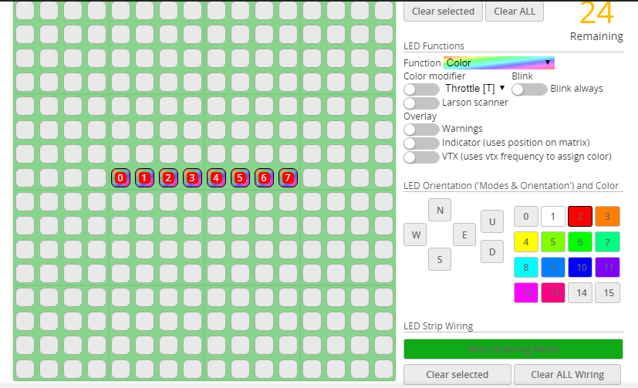
17.Troubleshooting
Warning:
Please read the cautions as follows, otherwise stability of your flight controller cannot be ensured, your flight controller will even get damaged.
● Keep focus on the polarity. Check carefully before power supply.
● Cut off the power when you connect, plug and pull anything.
● The refresh rate of PID and Gyroscope is up to 8K/8K.
after sales question:
1. After receiving the goods, it is found that the product can not be used normally. If the return to the factory is a quality problem, the repair service will be provided free of charge.
2. If the product is damaged due to improper operation, the repair service may be provided under the condition that the inspection can be repaired.
3. For domestic customers, please contact the after-sales service personnel. For overseas customers, please contact the official website for after-sales service.

Product daily problems
1.OSD garbled:
If you find garbled characters, please open Betaflight, click “OSD” .and click “Font Manager” clicks on “Upload Font” to update
- When plugged in the battery, the aircraft does not pass the self-test without "BBB" sound. There is only one sound.
Please check if the ESC agreement is correct

3.The spin of the aircraft keeps spinning
1. Please check if the propeller is correct
2. Please check if the motor direction is correct

